1. **Program to implement longjump**

**Note: save filename as setjump.c**

#include <stdio.h>

#include <stdlib.h>

#include <setjmp.h>

jmp_buf env; // for saving longjmpenvironmentint

int A();

int B();

int C();

int main()

{

int r, a=100;

printf("call setjmp to save environment\n");

if ((r=setjmp(env)) == 0)

{

A();

printf("normal return\n");

}

else

printf("back to main() via long jump, r=%d a=%d\n", r, a);

}

int A()

{ printf("enter A()\n");

B();

printf("exit A()\n");

}

int B()

{ printf("enter B()\n");

printf("long jump? (y|n) ");

if (getchar()=='y')

longjmp(env, 1234);

printf("exit B()\n");

}

**Output:**

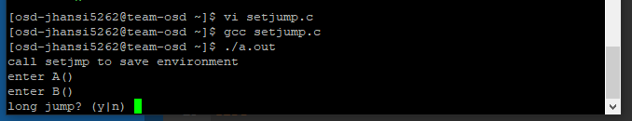

**2. Program for linking C library in assembly program**

**Note:** Save file name as welcome.s

.global main

.text

main: # This is called by C library's startup code

mov $message, %rdi # First integer (or pointer) parameter in %rdi

call puts # puts(message)

ret # Return to C library code

message:

.asciz "welcome" # asciz puts a 0 byte at the end

**Note**: use below command to run the program

$ gcc welcome.s && ./a.out

**Output:**

